数据库配置、公众号授权配置

目录：Application\Common\Conf\config.php

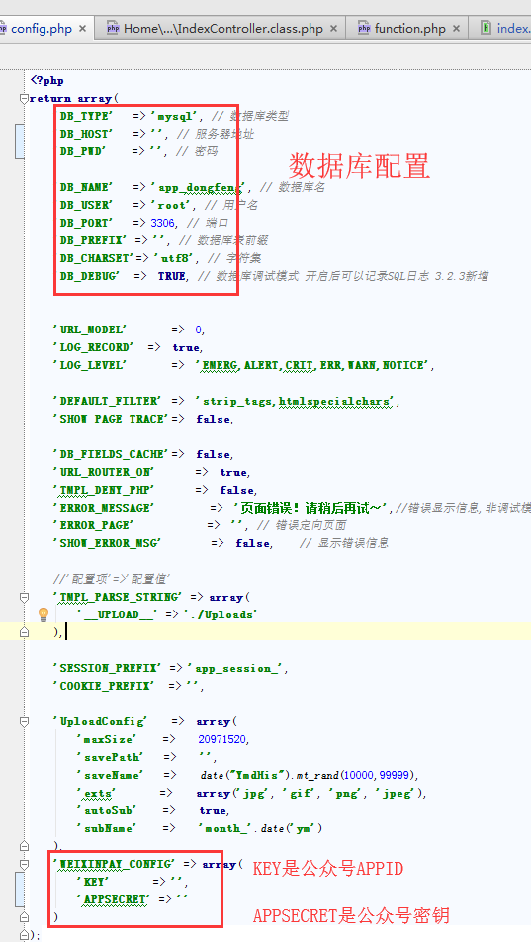

权限配置

Application

Pulibc/upload

Pulibc/uploads

这些目录都要设成777权限

域名修改：请修改成对应的域名

Application\Home\Controller\IndexController.class.php

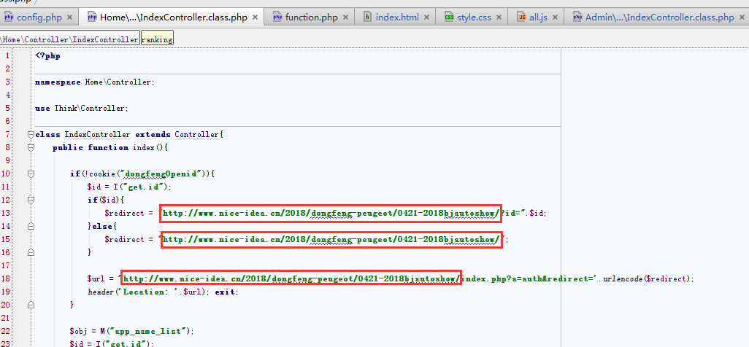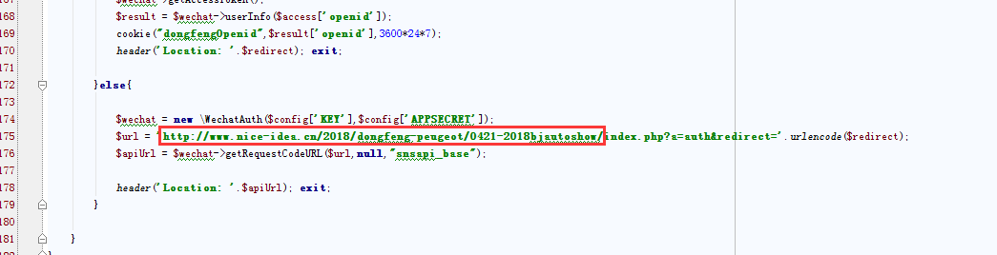

Application\Home\View\index.html

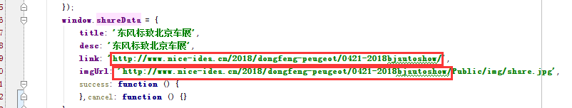

Public\js/all.js

